Reef 2050 Water Quality Research, Development and Innovation Strategy (2017–2022)

Stage 1: The Prioritised Knowledge Needs

# Executive summary

The quality of water entering the Reef from adjacent catchments remains one of the major management issues for protecting the Great Barrier Reef World Heritage Area. Continued advancements in, and understanding of, catchment to Reef water quality research, development and innovation are vital to addressing the issue. Investment over the last decade in Reef water quality research has been significant. Led by this strong investment, research has helped target on-ground efforts which have been successful in halting the decline in water quality.

The Reef 2050 Water Quality, Research, Development and Innovation Strategy (2017 – 2022) (RDI Strategy) builds on the actions to date and challenges partners and the broader community to capitalise on these investments and push forward the knowledge boundaries to achieve the [Reef 2050 Water Quality Improvement Plan](https://www.reefplan.qld.gov.au/about/)’s (Reef 2050 WQIP) targets, objectives and long-term outcome. While our understanding of water quality issues has increased over the past decade, so too has the expectation and demand for new knowledge to inform on-ground change. The variety and number of questions being asked by managers, landholders and the community continues to grow beyond the capacity of combined investment.

This strategy outlines the guiding principles around Reef water quality research and establishes a process to identify the most critical knowledge needs that must be answered and the research and development required to provide long-term solutions for improving the quality of water entering the Reef.

This RDI Strategy (2017-2022), differs from previous strategies in that it will be presented in two stages: Stage 1 – The Priority Knowledge Needs (this report) and Stage 2 – The Research Impact and Engagement Plan. This report outlines the knowledge needs identified in the [2017 Scientific Consensus Statement](https://www.reefplan.qld.gov.au/about/reef-science/scientific-consensus-statement/): Land Use Impacts on Great Barrier Reef Water Quality and Ecosystem Condition (2017 Scientific Consensus Statement) and consultation and engagement with over 100 science, policy and on-ground management experts and stakeholders.

Determining the most important management questions, and identifying how to answer them, requires a wide-range of expertise. End users of research, development and innovation such as landholders, extension officers, catchment and Reef managers, industry bodies, regional natural resource management bodies and conservation groups have helped identify the most important questions to ensure that activities are focused on achieving practical results and outputs that can be widely adopted and supported.

Through the consultation and engagement process, the knowledge needs have been refined and prioritised to guide the creation and implementation of the knowledge and research required to achieve the targets, objectives and long-term outcome of the Reef 2050 WQIP. The highest priority knowledge needs are presented below.

### Acknowledgments

The contribution of experts and stakeholders involved in the 2017 Synthesis Workshop, Human Dimensions Workshop, Bioavailable Nutrients Workshop, members of the Pesticide, Sediment, Nutrients and Human Dimensions working groups, marine scientific experts and authors of the 2017 Scientific Consensus Statement are acknowledged for their contributions. Members of the Independent Science Panel are also acknowledged for reviewing this report.

## Highest priority knowledge needs

All knowledge needs are considered a priority, however, some are considered a higher priority for immediate investment compared to others and as such, are ranked as either highest, moderate or lower priority. All identified knowledge needs with current investment have been ranked as a lower priority for new investment. The knowledge needs are separated into Biophysical and Human Dimensions themes. Contextual information supporting each of the knowledge needs is presented in Appendix 4. A brief summary of the contextual information is provided in the *key concepts* provided with each knowledge need.

### Biophysical themes

| **Research Theme** | **Highest priority knowledge needs**  (follow the hyperlinks for more detail on each knowledge need) |
| --- | --- |
| Sediment | 1. **What are the water quality benefits from restored/improved land condition as a result of improved grazing practices?***Key concepts: processes, timeframes, costs, hydrology, erosion drivers, role of ground cover, Forage* |
|  | 1. **What is the effectiveness, in terms of water quality benefits, costs and timeframes, of remediating gully and riparian areas? How can this information be used to target and prioritise areas for remediation?***Key concepts: gully, riparian and streambank erosion, climate and soil types, effectiveness measures, prioritisation, targeting* |
|  | 1. **Improve our understanding of the impacts of tree clearing on water quality going to the Reef?***Key concepts: streambanks, catchment hydrology, modelling, vegetation clearing thresholds* |
|  | 1. **What is the risk of the finest sediment fractions (<16 uM) to the Reef?***Key concepts: benthic light, turbidity, dominant particle size, erosion, storage and delivery of fine sediment, plumes versus resuspension, sedimentation, seagrass, coral* |
| Nutrients | 1. **Knowledge, data and tools to underpin a Nutrient Decision Support Tool.***Key concepts: variability in sugarcane nitrogen requirements, temporal and spatial complexity of soil, variable climate and management factors, site-specific recommendations, N application, organic sources, enhanced efficiency fertilisers, model-based decision support systems* |
|  | 1. **Validation of the water quality benefits (for the Reef) predicted from improved irrigation practices and water use efficiency.***Key concepts: deep drainage, surface water run-off, nitrogen, modelling, field validation* |
|  | 1. **Improved understanding of the complexities of paddock-scale nutrient budgets and the effect on water quality.***Key concepts: nutrient surplus, soil concentrations, losses to the environment, organic sources, plant nutrient demand, legumes, mill mud* |
| Particulate nutrients | 1. **What is the risk of bioavailable nutrients (primarily N and P) to coastal and marine ecosystems and what contribution are particulate nutrients making to the bioavailable nutrient pool?**   K*ey concepts: bioavailability, nitrogen and phosphorus forms, carbon, phytoplankton production, transformation processes, dispersion, residence times* |
|  | 1. **What are the delivery pathways of bioavailable particulate nutrients from different land uses and what happens to particulate nutrients between those sources and the end of the catchment?**   *Key concepts:**key sources, land use, nitrogen and phosphorus forms, carbon, transformation, particle size, generation rates, anthropogenic load, isotope studies, prioritisation and targeting* |
| Pesticide and other pollutants | 1. **Knowledge, data and tools to underpin a Pesticide Decision Support Tool.**  *Key concepts: sugarcane, horticulture, grains, bananas, mobility, ecotoxicity, soil type, half-lives, transport, fate* |
|  | 1. **What is the ecological risk of pesticides from other (non-sugar cane) land uses, including: horticulture, bananas, grains, grazing?** *Key concepts: insecticides, fungicides, nematicides, concentrations, exposure* |
|  | 1. **What are the observed ecological impacts that pesticides are having on coastal ecosystems, including wetlands?** *Key concepts: biomonitoring of insitu impacts, fate, transport, ecotoxicity* |
| Marine and coastal | 1. **Improve our understanding and modelling of the combined impact of pressures on the resilience of Reef and coastal ecosystems.** *Key concepts: resilience, recovery, spatial ecosystem models, high-quality observational data, seagrass, coral, tolerance thresholds and tipping points, poor water quality, climate change, extreme weather* |
|  | 1. **What is the spatial distribution and condition of habitats in the coastal and inshore marine ecosystems of the Great Barrier Reef?**   *Key concepts: habitat vulnerability, habitat map, asset map, condition assessment, ecological risk assessment, floodplain wetlands, floodplains, freshwater wetland and estuarine environments (mangrove and saltpan), fish and predator fish and non-Reef bioregions* |
|  | 1. **What are the detailed mechanisms and processes that directly link nutrient run-off to crown-of-thorns starfish larvae food sources and crown-of-thorns starfish outbreaks?**  *Key concepts: phytoplankton, nutrient concentrations, nutrient species and ratios, organic carbon, ‘threshold values’ for enhanced larvae survival* |
|  | 1. **What are the factors that foster or impede seagrass recovery after disturbance?** *Key concepts: seagrass meadow resilience, seed germination triggers, seed viability, seed bank thresholds, sediment conditions, species interactions* |
| Wetlands and treatment systems | 1. **What are the impacts of poor water quality on wetland coastal ecosystems?**   *Key concepts: values, wetland and coastal habitats function, poor water quality, response and tolerance, thresholds, multiple stressors, prioritisation framework, wetland type, quantitative risk assessment, sediment, dissolved and particulate nutrients pesticides* |
|  | 1. **How does poor water quality effect the ecological services wetlands provide to the Great Barrier Reef?**   *Key concepts: ecological services, wetland functions, protecting/rehabilitating wetlands and coastal habitats* |
|  | 1. **What is the capacity of wetlands to improve water quality from catchment to Reef**?   *Key concepts: assimilation rates and capacity, wetland type and characteristics, seasonal variation, hydrological regimes, maximise contaminant removal, load / concentration thresholds, sediment retention, nutrient filtering, land use* |

### Human Dimensions theme

| **Categories** | **Highest priority knowledge needs** |
| --- | --- |

|  |  |
| --- | --- |
| *Policies, programs and instruments* | 1. **How can we evaluate the relative effectiveness of the mix of policies, programs and instruments (collectively and individually) currently being used to drive improved land management?**   *Key concepts: systematic evaluation of delivery processes, social factors, systemic regulation, regional economies, cost benefit analysis, risk analysis, competition, effective land use management, governance* |
| *Partnerships* | 1. **Review and synthesise the opportunities and limitations of current partnership arrangements (at a range of levels) in delivering outcomes.**   *Key concepts: partnerships, engagement, cost-effectiveness, market mechanisms, Incentives, adaptiveness, governance* |
| *Networks that influence behaviour* | 1. **How can existing peer-based and other social networks encourage behaviours that improve water quality outcomes?**   *Key concepts: social networks, professional networks, community networks, economic networks, behaviour change, influencers, extension, values, collective governance, practice improvement* |
| *Land managers and their practices* | 1. **How can we use existing knowledge about the human dimensions of practice change to overcome barriers to adoption, increase practice uptake, identify and fill key knowledge needs in priority sectors?**   *Key concepts: behaviour change, barriers, motivations, knowledge, stewardship, social factors, economic factors, cultural factors, environmental factors, change mechanisms* |

# Contents

Executive summary 2

Acknowledgments 2

Highest priority knowledge needs 3

Biophysical themes 3

Human Dimensions theme 5

Contents 6

Introduction 8

How the RDI Strategy aids the implementation of the Reef 2050 WQIP 8

Objective, scope and approach of the RDI Strategy 9

Stage 1: The prioritised knowledge needs 10

Refinement and prioritisation of knowledge needs 11

Research themes 11

Consultation and engagement 11

Pathways to knowledge creation and implementation 13

Investment in research and development 13

Knowledge implementation and innovation 13

Full list of knowledge needs 15

Biophysical knowledge needs 16

Sediment knowledge needs 16

Nutrients 18

Particulate nutrients 19

Pesticides and other pollutants 20

Marine and coastal 22

Wetlands and treatment systems 24

Human Dimensions knowledge needs 25

Appendix 1: Methodology for prioritising Knowledge kneeds 27

Appendix 2: Human Dimensions consultation and engagement 29

Appendix 3: Particulate Nutrients consultation and engagement 30

Appendix 4 32

Biophysical themes 32

Sediment knowledge needs 32

Nutrient knowledge needs 34

Particulate Nutrients knowledge needs 36

Pesticide and Other Pollutants knowledge needs 39

Marine and Coastal knowledge needs 41

Wetlands and Treatment Systems 44

Human Dimensions theme 46

# Introduction

The Australian and Queensland governments have worked collaboratively to develop a Reef 2050 Long-Term Sustainability Plan (Reef 2050 Plan) for the Great Barrier Reef World Heritage Area that guides the protection and management of this iconic World Heritage Area through to 2050.

The five year [Reef 2050 Water Quality Improvement Plan](https://www.reefplan.qld.gov.au/about/) (Reef 2050 WQIP) is nested within the Reef 2050 Plan. In particular, the Reef 2050 WQIP seeks to improve the quality of water flowing from the catchments adjacent to the Reef. The Reef 2050 WQIP is based on the best available independent scientific advice, as provided by the 2017 Scientific Consensus Statement.

The five year Reef 2050 Water Quality Research, Development and Innovation Strategy (2017 – 2022) is a joint action of the Queensland and Australian governments outlined in the Reef 2050 WQIP. It supersedes earlier RDI strategies: the [Reef Water Quality Protection Plan RDI Strategy (2013-2018)](https://www.reefplan.qld.gov.au/implementation/assets/reefplan-research-development-innovation-strategy-2013-2018.pdf) and Department of Environment and Heritage Protection [Reef Water Quality RDI Strategy (2014-15 – 2018-19)](https://www.ehp.qld.gov.au/assets/documents/reef/reef-water-quality-strategy.pdf).

This RDI Strategy builds on the knowledge needs identified in the [2017 Scientific Consensus Statement](https://www.reefplan.qld.gov.au/about/reef-science/scientific-consensus-statement/). Through collaborations with research organisations and other partners, the RDI Strategy aims to guide the creation, and implementation of knowledge and research required to achieve the targets, objectives and long-term outcome of the Reef 2050 WQIP.

## How the RDI Strategy aids the implementation of the Reef 2050 WQIP

The Reef 2050 WQIP recognises the need to urgently increase efforts to improve the quality of water flowing to the Reef. It meets this challenge using an expanded scope of tailored solutions for *Responding to the Challenge* and *Enabling Delivery* (Figure 1). *Applying the best available science and knowledge* is identified as one of the key work areas (B1 – Figure 1) to support progress towards the targets, objectives and long-term outcome.

The Reef 2050 WQIP recognises the importance of knowledge creation for *applying the best available science and knowledge* in order to:

* support policy, programs and practical on-ground management to improve water quality outcomes
* underpin evidence-based decision-making
* inform on-ground actions to meet water quality improvement outcomes
* refine existing standards, regulations and planning frameworks of minimum practice standards for all industries
* inform land managers, communities, urban communities.

Action 4.1 of Reef 2050 WQIP addresses the need for guidance in creating the best available science and knowledge through the RDI Strategy:

Identify, prioritise and fill knowledge needs through the Reef 2050 Water Quality Research, Development and Innovation Strategy.

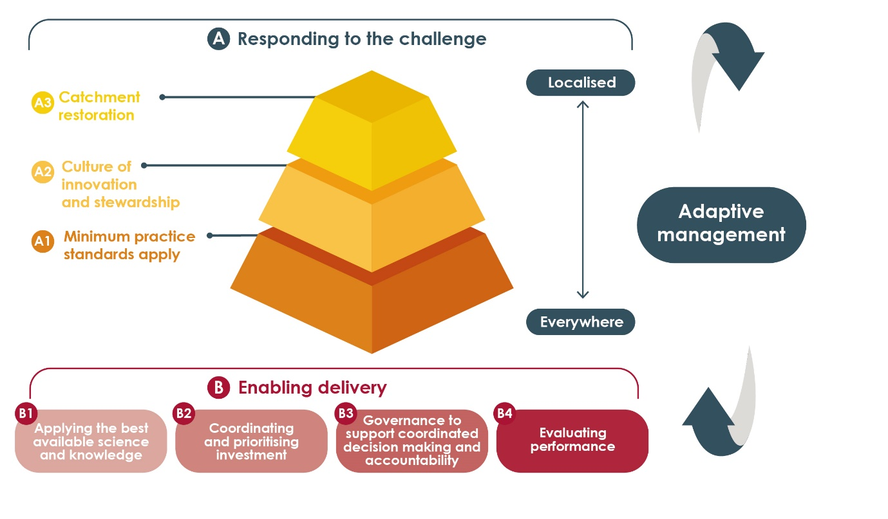

Figure 1. Implementing the Reef 2050 WQIP.

## Objective, scope and approach of the RDI Strategy

The RDI Strategy is the conduit for capturing the outstanding knowledge needs and guiding knowledge creation (through investment in research and development), knowledge implementation and innovation (Figure 2). The knowledge needs are sourced from the [2017 Scientific Consensus Statement](https://www.reefplan.qld.gov.au/about/reef-science/scientific-consensus-statement/), previous RDI strategies, expert opinion and stakeholder engagement.

The **2017 Scientific Consensus Statement** reviews the significant advances in scientific knowledge of water quality issues in the Great Barrier Reef. Produced by a multidisciplinary group of scientists, with oversight from the Reef Independent Science Panel, this plan supports the development of the Reef 2050 Water Quality Improvement Plan 2017–2022 and underpins water quality investment decisions.

Given the increased urgency for improving water quality for the Reef – with regards to the back-to-back bleaching events and severe cyclones – the vision for this RDI Strategy is to ensure that knowledge creation through research and development is focused, practical and readily implemented into policy, programs and on-ground management to get the most effective outcomes in the most efficient way.

It differs from previous strategies in that it will be delivered in two stages:

Stage 1: **The prioritised knowledge needs** – A high level guide to inform researchers, research investors and end users of the priority knowledge needs for achieving the targets, objectives and outcome of the Reef 2050 WQIP.

Stage 2: **Research impact and engagement plan** – A plan to aid the implementation and innovation of new science and knowledge through understanding research impact and engagement. The aim of Stage 2 is to (i) engage with researchers to identify practical pathways for research and development to fill the priority knowledge needs, and (ii) identify processes for knowledge implementation and innovation through understanding research impact and engagement of end users. Stage 2 will be delivered in a second report.

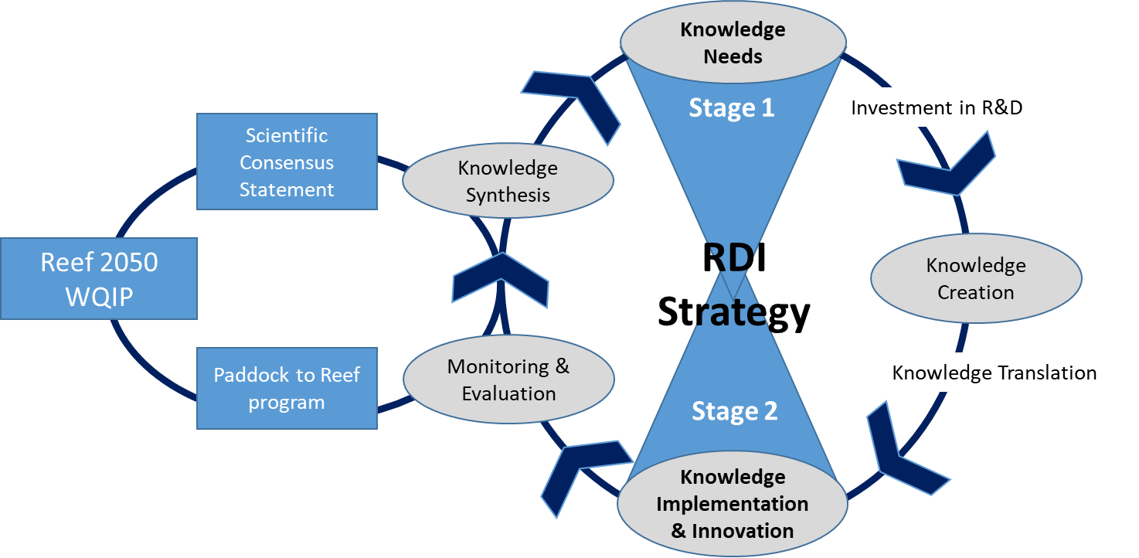

Figure 2. How the RDI Strategy guides the knowledge cycle.

# Stage 1: The prioritised knowledge needs

The **objective** of Stage 1 was to collaborate with research organisations and other partners to refine and prioritise the identified knowledge needs based on their significance for achieving the [outcome, targets and objectives of the Reef 2050 WQIP](https://www.reefplan.qld.gov.au/about/). This report provides a guide for researchers, research investors and end users to focus research and development towards the prioritised knowledge needs.

The **scope** of the RDI Strategy is the same as the Reef 2050 WQIP. It addresses land based pollutant sources including all agricultural activities, urban diffuse, point source and industrial discharge. It also includes specific consideration of the human dimensions of achieving water quality improvements. Therefore, the RDI Strategy covers the biophysical and human dimensions research, development and innovation related to the effects of broadscale land use on water quality and Reef health.

## Refinement and prioritisation of knowledge needs

The knowledge needs were sourced from the 2017 Scientific Consensus Statement, previous RDI strategies, expert opinion and stakeholder engagement. A multi-stage process was carried out to focus the knowledge needs to guide investment in research and development (Figure 3). The knowledge needs were organised into multiple research themes followed by a process of consultation and engagement for further refinement and prioritisation.

The knowledge needs for monitoring and evaluation specifically address the needs of the Paddock to Reef Integrated Monitoring, Modelling and Reporting Program, which are covered in Stage 2 of the RDI Strategy - identifying practical pathways for research and development to fill the priority knowledge needs.

### Research themes

The knowledge needs were categorised into research themes to broadly align with the Reef 2050 WQIP targets and objective. For clarity, these have been distinguished as biophysical and human dimensions themes:

Biophysical themes:

* 1. Sediment,
  2. Nutrients,
  3. Particulate nutrients
  4. Pesticides and other pollutants,
  5. Marine and coastal
  6. Wetlands and treatment systems

Human Dimensions theme separated into four categories:

1. Policies, programs and instruments
2. Partnerships
3. Networks that influence behaviour
4. Land managers and their practices

As with the previous RDI Strategy, this strategy does not cover climate change research specifically, but the importance of investigating interactions between water quality and climate change is recognised.

### Consultation and engagement

Multiple stages of consultation and engagement were carried out with more than 100 science, policy and on-ground extension and management experts over a six month period to prioritise and refine the knowledge needs presented in this report.

Engagement with groups and individuals occurred through:

* the Great Barrier Reef Synthesis Workshop,

**The Great Barrier Reef Synthesis Workshop** is held regularly to bring together scientists, policy makers, program managers and Traditional Owners to support the ongoing integration of research, policy making and management practice.

* the Human Dimensions Workshop,
* the Particulate Nutrient Workshop
* the Sediment, Nutrients, Pesticides and Human Dimensions Working Groups,
* marine experts.

The results of the engagement process were evaluated through consultation with the lead authors of the 2017 Scientific Consensus Statement and the Independent Science Panel.

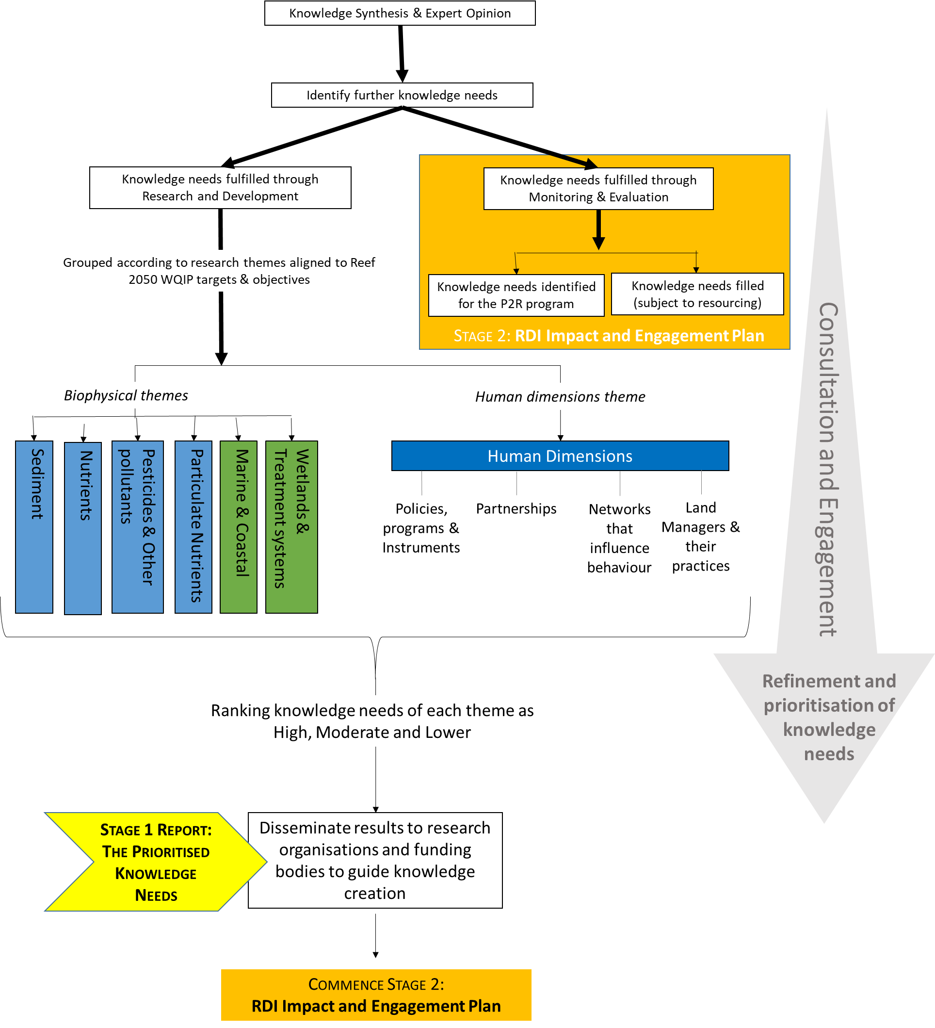

**Figure 3: Flow diagram of the steps followed for the knowledge needs prioritisation process.**

# Pathways to knowledge creation and implementation

Refining and prioritising the Reef water quality knowledge needs helps to focus knowledge creation towards achieving the Reef 2050 WQIP targets, objectives and long-term outcome. The Australian and Queensland governments acknowledge the pivotal role that funding programs and research organisations play in Reef water quality knowledge creation, along with the concepts of transdisciplinary research, industry collaboration, stakeholder engagement and research impact.

### Investment in research and development

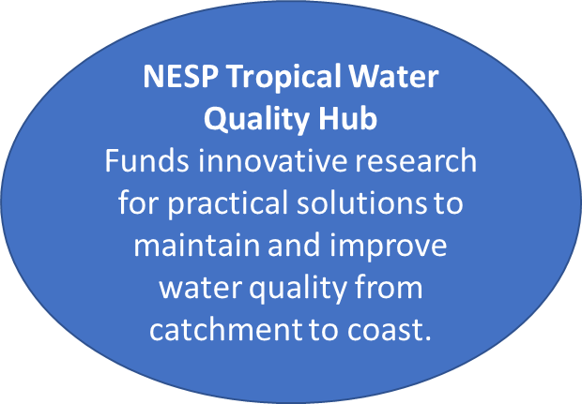The key programs that contribute to Reef water quality research under the RDI Strategy include the [National Environmental Science Program’s Tropical Water Quality Hub](http://nesptropical.edu.au/) and the Queensland Government [Science in the Paddock Program](https://www.qld.gov.au/environment/agriculture/sustainable-farming/reef-program).

Other programs that conduct research focused on broader goals (e.g. industry productivity) may also help to meet knowledge needs relevant to Reef water quality. Ongoing sources of research investment include:

* Australian Government investment in university research through the Australian Research Council
* Australian Government investment in research providers such as CSIRO, the Australian Institute of Marine Science and the Bureau of Meteorology
* Queensland Government investment in research by state agencies such as the Department of Agriculture and Fisheries, Department of Environment and Science and Department of Natural Resources, Mines and Energy
* The Australian Government Department of the Environment and Energy and Great Barrier Reef Marine Park Authority invest in individual research projects
* Industry-based research and development organisations (such as Sugar Research Australia Ltd, Meat and Livestock Association) which are funded through industry levies and government contributions
* Nongovernment organisations such as the Great Barrier Reef Foundation and WWF.

### Knowledge implementation and innovation

*Stage 2: RDI Impact and Engagement Plan*

Research, development and innovation relevant to Reef water quality must focus on the needs of end users to ensure effective and efficient uptake of research outputs to deliver on-ground improvements. How research outputs are received and implemented by end users influences the impact of research on the broader community. With a strong user focus, research, development and innovation activities have the potential to influence industry development, all aspects of the delivery chain, new product development, new policies and a revitalised and up-to-date extension network.

Research impact and engagement is recognised as an important component for prioritising and commissioning applied research. Developing a Research Impact and Engagement Plan for Reef water quality research will align with frameworks for research evaluation implemented nationally and internationally. The Reef 2050 Water Quality Research Impact and Engagement Plan will be delivered in the second stage of the RDI Strategy, providing guidance for determining research impact, engaging with end users and disseminating and communicating research outputs.

*Innovation*

The Great Barrier Reef Innovation Fund is a Queensland Government’s investment over four years (2016–2020) as part of the Queensland Reef Water Quality Program to encourage innovation and fresh thinking around on-ground projects in Reef catchments. Broadly the investment is broken down into four major themes: agricultural management, catchment restoration, treatment systems and water quality monitoring. As of June 2018, approximately $8 million is allocated against innovative projects, with matched funding from proponents and other government agencies more than doubling the fund’s investment into innovation. Some of the key investments include:

* trialling of denitrifying bioreactors and constructed wetlands in Great Barrier Reef catchments
* working with Greening Australia to trial innovative gully remediation techniques to reduce sediment run-off
* in collaboration with the Australian Government, the trial of enhanced efficiency fertilisers in the cane industry
* through the Advance Queensland Small Business Innovation Research (SBIR) initiative, coordinating a challenge to develop significantly cheaper water nitrogen sensors.

# Full list of knowledge needs

All gaps are considered a priority. However, some are considered a higher priority for immediate investment compared to others and as such, are ranked as either high, moderate or lower priority. All identified knowledge needs with current investment have been ranked as a lower priority for new investment. The knowledge needs are separated into Biophysical and Human Dimensions themes. Contextual information supporting each of the knowledge needs is presented in Appendix 4. A brief summary of the contextual information is provided in the *key concepts* provided with each knowledge need.

# Biophysical knowledge needs

Back to Executive Summary

Back to Research Themes

## Sediment



The sediment knowledge needs were prioritised based on these [Reef 2050 Water Quality Improvement Plan targets](https://www.reefplan.qld.gov.au/about/).

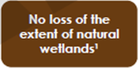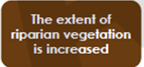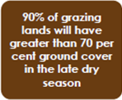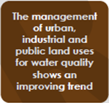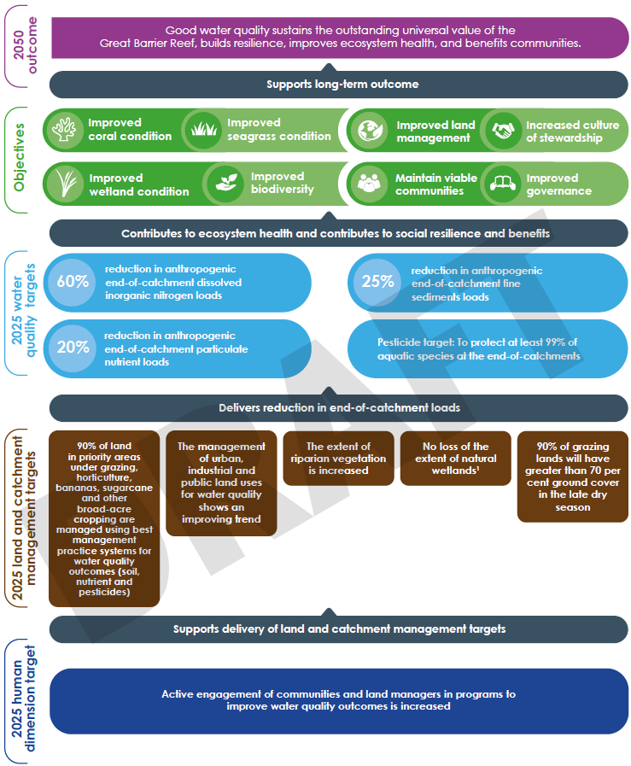

This research theme covered all identified knowledge needs associated with sediment from its source at the paddock to its transport to the Reef. Ecological impacts of sediment on Great Barrier Reef ecosystems were not covered under this theme, but can be found in the marine and coastal theme and the wetlands and treatment systems theme. Similarly, the knowledge needs specific to particulate nutrients are presented under the particulate nutrients theme, a sub-section of the nutrients theme.

|  |  |  |  |  |  |  |  |  |
| --- | --- | --- | --- | --- | --- | --- | --- | --- |
| **Highest priority**  (follow the hyperlinks for more detail on each knowledge need) | | | | | | | | |
| S.1 What are the water quality benefits from recovered land condition as a result of improved grazing practices? *Key concepts: processes, timeframes, costs, hydrology, erosion drivers, role of ground cover, Forage.* | | | S.2 What is the effectiveness, in terms of water quality benefits, costs and timeframes, of remediating gully and riparian areas? How can this information be used to target and prioritise areas for remediation?*Key concepts: gully, riparian and streambank erosion, climate and soil types, effectiveness measures, prioritisation, targeting.* | | S.3 What are the impacts of tree clearing on water quality going to the Reef?*Key concepts: streambanks, catchment hydrology, modelling, vegetation clearing thresholds*. | | S.4 What is the risk of the finest sediment fractions (<16 uM) to the Reef?*Key concepts: benthic light, turbidity, dominant particle size, erosion, storage and delivery of fine sediment, plumes versus resuspension, sedimentation, seagrass, coral*. | |
| **Moderate priority**  (follow the hyperlinks for more detail on each knowledge need) | | | | | | | | |
| S.5 Better understanding of sediment sources and processes in priority catchments.  *Key concepts: natural/baseline levels, spatial locations, gully, streambank, and hillslope erosion processes, other land uses (e.g. roads, cane, bananas, cropping etc.).* | | | | | | | | |
| **Lower priority**  (follow the hyperlinks for more detail on each knowledge need) | | | | | | | | |
| S.6 Better understanding of the circumstances that cause gullies to form. *Key concepts: predicting where gullies form/are,. Predicting gully properties and gully erosion/expansion rate.* | S.7 What are the pre-development loads of sediments?*Key concepts: pre-development conditions, model estimates.* | | S.8 What are the effects of long-term natural climate fluxes on sediment loads? | | S.9 What is the impact of cane drains on sediment/erosion and water quality? | | S.10 What is the contribution of sediment from unsealed roads? Risk assessment to identify significance, mapping. | |

## Nutrients

Back to Executive Summary

Back to Research Themes

This research theme covered all identified knowledge needs associated with nutrients (nitrogen and phosphorus) from their source at the paddock to their transport to the Reef. Ecological impacts of nutrients on Great Barrier Reef ecosystems were not covered under this theme, but can be found in marine and coastal and wetlands and treatment systems.



The nutrient knowledge needs were prioritised based on these [Reef 2050 Water Quality Improvement Plan targets](https://www.reefplan.qld.gov.au/about/).

The knowledge needs specific to particulate nutrients were assessed separately through the Bioavailable Nutrients Workshop and are presented here as a sub-section of the nutrients theme.

|  |  |  |  |  |  |
| --- | --- | --- | --- | --- | --- |
| **Highest priority**  (follow the hyperlinks for more detail on each knowledge need) | | | | | |
| N.1 Knowledge, data and tools to underpin a Nutrient Decision Support Tool. *Key concepts: variability in sugarcane nitrogen requirements, temporal and spatial complexity of soil, variable climate and management factors, site-specific recommendations, N application, organic sources, enhanced efficiency fertilisers, model-based decision support systems.* | | | N.2 Validation of the water quality benefits (for the Reef) predicted from improved irrigation practices and water use efficiency. *Key concepts: deep drainage, surface water run-off, nitrogen, modelling, field validation*. | | N.3 Improved understanding of the complexities of paddock-scale nutrient budgets and the effect on water quality. *Key concepts: nutrient surplus, soil concentrations, losses to the environment, organic sources, plant nutrient demand, legumes, mill mud.* |
| **Moderate priority**  (follow the hyperlinks for more detail on each knowledge need) | | | | | |
| N.4 Better understanding of the contribution of the nutrient sources from other land uses to poor water quality going to the Reef. *Key concepts: fertilised grazing lands, horticulture production areas, bananas, grains.* | | | | | |
| **Lower priority**  (follow the hyperlinks for more detail on each knowledge need) | | | | |
| N.5 What are the pre-development loads of nutrients? *Key concepts: pre-development conditions, model estimates.* | N.6 What is the role of short-term natural climate fluctuation on end-of-catchment nutrient fluxes?  *Key concepts: nutrient fluxes, climate fluctuation, water quality targets.* | | N.7 Better understanding of how enhanced efficiency fertilisers can improve water quality for the Reef.  *Key concepts: water quality benefits, compatibility with variable soil and climate conditions.* | |

### Particulate nutrients

Back to Executive Summary

Back to Research Themes

Particulate nutrients knowledge needs are presented as a sub-section of the nutrient theme. This sub-theme covered all identified knowledge needs associated with particulate nutrients (nitrogen and phosphorus) from their source at the paddock to their transport to the Reef. The ecological impacts of particulate nutrients on Great Barrier Reef ecosystems were also covered under this theme.

The particulate nutrient knowledge needs were prioritised based on these [Reef 2050 Water Quality Improvement Plan targets](https://www.reefplan.qld.gov.au/about/)



|  |  |  |  |
| --- | --- | --- | --- |
| **Highest priority**  (follow the hyperlinks for more detail on each knowledge need) | | | |
| PN.1 What is the risk of bioavailable nutrients (primarily N and P) to coastal and marine ecosystems and what contribution are particulate nutrients making to the bioavailable nutrient pool?  K*ey concepts: bioavailability, nitrogen and phosphorus forms, carbon, phytoplankton production, transformation processes, dispersion, residence times.* | | PN.2 What are the delivery pathways of bioavailable particulate nutrients from different land uses and what happens to particulate nutrients between those sources and the end of the catchment?  *Key concepts:* *key sources, land use, nitrogen and phosphorus forms, carbon, transformation, particle size, generation rates, anthropogenic load, isotope studies, prioritisation and targeting.* | |
| **Moderate priority**  (follow the hyperlinks for more detail on each knowledge need) | | |
| PN.3 What are the primary catchment sources of end-of-catchment bioavailable nutrient loads? *Key concepts: key sources, land use, nitrogen and phosphorus forms, carbon, particle size, generation rates, anthropogenic load, isotope studies, prioritisation and targeting.* | PN.4 What contribution of the end of catchment bioavailable nutrient load comes from landscape erosion, including surface (hillslope erosion) and sub-surface erosion (gullies and streambanks)?  K*ey concepts: key sources, estimated yields, bioavailable nutrients, isotope studies, prioritisation and targeting.* | |

## Pesticides and other pollutants

Back to Executive Summary

Back to Research Themes



This research theme covered all identified knowledge needs associated with pesticides and other pollutants from their source to their transport to the Reef. Other pollutants were those identified in the 2017 Scientific Consensus Statement as ‘Emerging Contaminants’ and included plastics, marine debris, antifouling paints, personal care products, nanomaterials and PFOS/PFAS. Ecological impacts of pesticides and other pollutants on Great Barrier Reef ecosystems were maintained within this theme, but may also link with knowledge needs grouped under marine and coastal and wetlands and treatment systems.

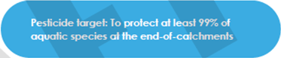

The pesticide and other pollutants knowledge needs were prioritised based on these [Reef 2050 Water Quality Improvement Plan targets](https://www.reefplan.qld.gov.au/about/).

|  |  |  |  |  |  |  |  |
| --- | --- | --- | --- | --- | --- | --- | --- |
| **Highest priority**  (follow the hyperlinks for more detail on each knowledge need) | | | | | | | |
| PP.1 Knowledge, data and tools to underpin a Pesticide Decision Support Tool.  *Key concepts: sugarcane, horticulture, grains, bananas, mobility, ecotoxicity, soil type, half-lives, transport, fate.* | | | PP.2 What is the ecological risk of pesticides from other (non-sugar cane) land uses including horticulture, bananas, grains, grazing?  *Key concepts: insecticides, fungicides, nematicides, concentrations, exposure.* | | | PP.3 What are the observed ecological impacts that pesticides are having on coastal ecosystems, including wetlands? *Key concepts: biomonitoring of insitu impacts, fate, transport, ecotoxicity.* | |
| **Moderate priority**  (follow the hyperlinks for more detail on each knowledge need) | | | | | | | |
| PP.4 What is the current and future risk of plastic pollution in Great Barrier Reef ecosystems? *Key concepts: micro-plastics, nano plastics, marine debris, monitoring programs, management strategies.* | | | | | PP.5 Do metabolites pose a risk to aquatic ecosystems relative to the parent compounds and what does this mean for the management of the parent compounds?  *Key concepts: pesticide metabolites, ecotoxicity, ecological risk* | | |
| **Lower priority**  (follow the hyperlinks for more detail on each knowledge need) | | | | | | | |
| PP.6 What are the water quality impacts from ports?  *Key concepts: dredge material, land-based disposal, comparison with terrestrial run-off.* | PP.7 How can urban water cycle elements (potable water, wastewater and storm water) be integrated in a coordinated way to minimise urban run-off?  *Key concepts: storm water quality, water cycle management.* | | PP.8 What is the effectiveness of urban water management practices (often adopted from temperate regions) under extreme tropical conditions (e.g. effects of extreme rainfall and long dry periods on vegetated systems)?  *Key vegetated treatment systems, modifications of design.* | | | PP.9 What is the risk of other/ emerging contaminants and how should we manage these? e.g. antifouling paints, personal care products, nanomaterials, metals, poly-fluoroalkyl substances/ Perfluorooctane sulfonate (PFOS/PFAS).  *Key concepts: current and future risk, monitoring programs, management strategies.* | |

## Marine and coastal

Back to Executive Summary

Back to Research Themes

This research theme covered all identified knowledge needs associated with the impacts on marine and coastal ecosystems from poor water quality. Knowledge needs specific to wetlands and treatment systems were separated from the marine and coastal theme and are presented under the wetlands and treatment systems research theme. Ecological impacts to marine and coastal ecosystems from particulate nutrients were assessed separately through the Bioavailable Nutrients Workshop and are presented under the particulate nutrients theme, a sub section of the nutrients research theme.



The marine and coastal knowledge needs were prioritised based on these [Reef 2050 Water Quality Improvement Plan targets and objectives](https://www.reefplan.qld.gov.au/about/).



|  |  |  |  |  |  |  |
| --- | --- | --- | --- | --- | --- | --- |
| **Highest priority**  (follow the hyperlinks for more detail on each knowledge need) | | | | | | |
| MC.1 Improve our understanding and modelling of combined impact of pressures on the resilience of Reef and coastal ecosystems. *Key concepts: resilience,, recovery,, spatial ecosystem models,, high quality observational data,, seagrass,, coral,, tolerance thresholds and tipping points,, poor water quality,, climate change,, extreme weather.* | | MC.2 What is the spatial distribution and condition of habitats in the coastal and inshore marine ecosystems of the Great Barrier Reef?  *Key concepts: habitat vulnerability, habitat map, asset map, condition assessment, ecological risk assessment, floodplain wetlands, floodplains, freshwater wetland and estuarine environments (mangrove and saltpan), fish and predator fish and non-Reef bioregions.* | | MC.3 What are the detailed mechanisms and processes that directly link nutrient run-off to crown-of-thorns starfish larvae food sources and crown-of-thorns starfish outbreaks?  *Key concepts: COTS, phytoplankton, nutrient concentrations, nutrient species and ratios, organic carbon, ‘threshold values’ for enhanced larvae survival.* | | MC.4 What are the factors that foster or impede seagrass recovery after disturbance?  *Key concepts: seagrass meadow resilience, seed germination triggers, seed viability, seed bank thresholds, sediment conditions, species interactions.* |
| **Moderate priority**  (follow the hyperlinks for more detail on each knowledge need) | | | | | | |
| MC.5 How can we measure connectivity between the freshwater-estuarine-marine ecosystems to demonstrate/quantify the importance of protecting coastal ecosystems to protect the GBR?  *Key concepts: quantify connectivity, loss, modification, degradation of coastal ecosystems, modelling, ecological risk assessment* | | | | MC.6 What are the priority freshwater and estuarine barriers for mitigation or removal to improve water quality and fish passage in coastal ecosystems? *Key concepts: fish passage, physical and biochemical barriers, baseline data* | | |
| **Lower priority**  (follow the hyperlinks for more detail on each knowledge need) | | | | | | |
| MC.7 What are the water quality and climatic impacts to seagrass habitats in the Great Barrier Reef and what are the rates of acclimatisation and adaptation of seagrass to those impacts?  *Key concepts: function and condition, temporal and seasonal variability in impacts, poor water quality, climate change, nutrient enriched water, pesticides, sedimentation, climate change*. | | MC.8 What are the impacts of seagrass loss to the species and ecosystems dependent on them?  *Key concepts: associated fauna and/or multi-species fisheries, dugongs, turtles, changes in community composition.* | | MC.9 Improved understanding of the factors linked with coral thermal tolerance, and the scope and rates of acclimatisation and adaptation of coral reef taxa.  *Key concepts: nutrients, nutrient ratios, light/turbidity, temperature and light, water quality, recovery from bleaching, climate change.* | | |

## Wetlands and treatment systems



Back to Executive Summary

Back to Research Themes



This research theme covers all identified knowledge needs associated with wetlands and treatment systems. This theme covers the impacts of poor water quality on wetlands as well as the role wetlands and treatment systems play in improving water quality and other ecological services wetlands provide for the Reef.

The wetlands and treatment systems knowledge needs were prioritised based on these [Reef 2050 Water Quality Improvement Plan targets and objectives](https://www.reefplan.qld.gov.au/about/).

|  |  |  |
| --- | --- | --- |
| **Highest priority**  (follow the hyperlinks for more detail on each knowledge need) | | |
| WT.1 What are the impacts of poor water quality on wetland coastal ecosystems?  *Key concepts: values, wetland and coastal habitats function, poor water quality, response and tolerance, thresholds, multiple stressors, prioritisation framework, wetland type, quantitative risk assessment, sediment, dissolved and particulate nutrients pesticides.* | WT.2 How does poor water quality effect the ecological services wetlands provide to the Great Barrier Reef?  *Key concepts: ecological services, wetland functions, protecting/rehabilitating wetlands and coastal habitats.* | WT.3 What is the capacity of wetlands to improve water quality from catchment to Reef?  *Key concepts: assimilation rates and capacity, wetland type and characteristics, seasonal variation, hydrological regimes, maximise contaminant removal, load / concentration thresholds, sediment retention, nutrient filtering, land use.* |

|  |  |
| --- | --- |
| **Moderate priority**  (follow the hyperlinks for more detail on each knowledge need) | |
| WT.4 Develop a conceptual understanding of pesticides in natural, near natural and artificial wetlands including their transport, fate and retention?  *Key concepts: recycling pits, natural and near natural palustrine, riverine and lacustrine wetlands, fate, breakdown products and half-lives, transport, retention capacity, favourable wetland characteristics, variability.* | WT.5 What is the spatial distribution of groundwater dependent ecosystems and what are their ecological function?  *Keywords: map, wetlands* |

|  |  |
| --- | --- |
| **Lower priority**  (follow the hyperlinks for more detail on each knowledge need) | |
| WT.6 What is the impact of weed mat infestations on coastal and marine ecosystems of the Great Barrier Reef? *Key concepts: identification, mapping.* | WT.7 What is the effectiveness, efficiency and costs of treatment systems for removing nutrients?  *Key concepts: favourable combination of location, treatment system and land use, assimilation capacity, favourable treatment characteristics, climate/hydrology.* |

## Human dimensions

Back to Executive Summary

Back to Research Themes

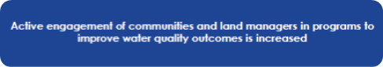

The human dimensions knowledge needs were prioritised based on the [Reef 2050 Water Quality Improvement Plan targets](https://www.reefplan.qld.gov.au/about/).

The human dimensions theme draws on the 2017 Scientific Consensus Statement and the RIMREP Human Dimensions Final Report. Some of the identified knowledge needs address issues that relate to establishing effective monitoring and evaluation, although the priority for all questions is how best to achieve effective and timely water quality outcomes. Underpinning all questions is the need to investigate how to harness shared community values to accelerate adoption of practice change in Reef communities. These gaps have been classified as high, moderate and lower priority for investment, however can alternatively be classified in terms of their priority in providing short- or medium-term outcomes.

| **Priority** | **Human Dimension Categories**  (follow the hyperlinks for more detail on each knowledge need) | | | |
| --- | --- | --- | --- | --- |
| **Policies, programs and instrumentsa** | **Partnershipsb** | **Networks that influence behaviourc** | **Land managers and their practicesd** |
| **Highest** (short-term) | HD.1 How can we evaluate the relative effectiveness of the mix of policies, programs and instruments (collectively and individually) currently being used to drive improved land management?  *Key concepts: Systematic evaluation of delivery processes, social factors, systemic regulation, regional economies, cost benefit analysis, risk analysis, competition, effective land use management, governance.* | HD.2 Review and synthesise the opportunities and limitations of current partnership arrangements (at a range of levels) in delivering outcomes.  *Key concepts: Partnerships, engagement, cost-effectiveness, market mechanisms, Incentives, adaptiveness, governance.* | HD.3 How can existing peer-based and other social networks encourage behaviours that improve water quality outcomes?  *Key concepts: Social networks, professional networks, community networks, economic networks, behaviour change, influencers, extension, values, collective governance, practice improvement.* | HD.4 How can we use existing knowledge about the human dimensions of practice change to overcome barriers to adoption, increase practice uptake, identify and fill key knowledge needs in priority sectors?  *Key concepts: Behaviour change, barriers, motivations, knowledge, stewardship, social factors, economic factors, cultural factors, environmental factors, change mechanisms.* |
| **Moderate** (short- and medium-term) | HD.5 How can we improve the design and delivery of the current mix of policies, programs and instruments?  *Key concepts: Optimal program/policy design, cost-effectiveness, social factors, supply chains, collaborative design, governance* |  | HD.6 How can existing supply chains and markets encourage behaviours that improve water quality outcomes?  *Key concepts: Supply chains, markets, behaviour change, public vs private outcomes.* |  |
| **Lower** (medium-term) | HD.7 How will changes in land use (and the underlying drivers of land use change e.g. climate, market, policy) influence the ability of communities and stakeholders to manage water quality effectively?  *Key concepts: Consequences of land-use changes, regulatory change, market drivers, climate drivers, policy drivers, practice and cultural change, regional economies, systemic regulation, governance, social factors.* |  | HD.8 How can media and community narratives encourage behaviours that improve water quality outcomes?  *Key concepts: Media, community, narrative, behaviour change, values, engagement.* |  |

a Policies – government legislation and regulation, plans (e.g. Reef 2050 Plan), policy statements; Programs – e.g. Queensland Reef Water Quality Program, Reef Trust Program; Instruments – e.g. best management practice programs, market-based initiatives, extension, education, incentives.

b *Partnerships* such as natural resource management (NRM) partnerships, alliances and regional report cards etc.

c *Definition:* Understanding the networks and narratives in place (peer, market, media and community) that influence behaviours, and thus practice uptake to improve water quality outcomes.

d *Definition:* Ensuring we utilise and learn from current human dimensions knowledge around land managers and their practices and identifying what we still don’t know.

# Appendix 1: Methodology for prioritising knowledge needs

**Sourcing and collating the knowledge needs**

The knowledge needs were first classified for ‘research and development’ or ‘monitoring and evaluation’ and assigned to a research theme. The knowledge needs were refined to approximately 15 - 20 broad (overarching) research and development questions, within each research theme, to aid with the prioritisation process at the Synthesis Workshop.

**Supporting information – context of the knowledge needs**

Supporting information to provide context for each of the knowledge needs was collated from the following:

* The knowledge needs that underpinned the broad knowledge needs (mentioned above).
* A summary of the established and current knowledge relating to the knowledge need extracted from the 2017 Scientific Consensus Statement.
* Related knowledge needs from the Reef Water Quality Protection Plan RDI Strategy (2013-2018) along with additional relevant information presented in the Evaluation Report (Hammill, 2016) that came under the headings:
  + ‘Gaps still remaining’
  + ‘Emerging responses’
  + ‘Projects initiated in 2013-2016’.
* For the pesticide theme only – related knowledge needs and contextual background extracted from the Pesticide Synthesis Report (Devlin et al, 2015).

The supporting information for the knowledge needs were provided to the attendees of the Synthesis Workshop, members of the working groups and the Independent Science Panel to aid in the prioritisation of the knowledge needs.

**The Great Barrier Reef Synthesis Workshop: ‘Knowledge to Support Delivery’**

The key objectives for the workshop session Knowledge to Support Delivery were to qualitatively rank the knowledge needs, in terms of their priority to be funded and delivered through research, using two approaches:

1. Group consensus – which aimed to prioritise the broad knowledge needs (into high/medium/low groupings) based on the ‘big picture’ – i.e. water quality targets and objectives
2. Individual opinion – which aimed to examine the research priorities of people with different work needs; from a science, policy and on-ground perspective.

For the group consensus workshop attendees self-organised themselves into one of five groups based on the research themes. The groups were asked to organise the broad knowledge needs as high, moderate or lower in terms of their priority for achieving the targets, objectives and long-term outcome the Reef 2050 WQIP. Lastly, the groups were asked to add any additional knowledge needs that had not been included and re-word/edit the broad knowledge needs if needed. The supporting information was provided to aid the process. Individuals were then asked to identify four knowledge needs (across any/all themes) that were a priority for their own work needs.

It should be noted that the Human Dimensions group could not come to a group consensus to prioritise the knowledge needs prepared before the workshop. As a result, a Human Dimensions workshop was organised to prepare and prioritise the knowledge needs for Human Dimensions research.

**Working group feedback**

The outcomes from the Synthesis Workshop, along with the relevant supporting information, were synthesised and sent to members of the Pesticide, Sediment, Nutrient Use Efficiency and Human Dimensions Working Groups. The marine and coastal research priorities were sent to relevant experts. Working group members were asked to provide feedback on whether they agreed with the wording and priority assigned to each knowledge need at the workshop and provide any additional comments. Feedback was collated and presented to the Independent Science Panel.

**Finalisation of knowledge needs**

The wording of the knowledge needs was finalised and reviewed by authors from the 2017 Scientific Consensus Statement (and/or experts from the working groups) and approved by the Independent Science Panel and the Reef 2050 Executive Steering Committee.

Back to Consultation and Engagement

# Appendix 2: Human dimensions consultation and engagement

In November 2017, an initial Synthesis Workshop was held in Townsville with highly invested water quality stakeholders and experts to begin prioritisation discussions for the RDI Strategy. The social and economic research priorities identified from the 2017 Scientific Consensus Statement were examined. This was followed by a discussion to prioritise and refine the key gaps. Following this workshop, information was sent to a broader group of stakeholders to rank the highest research priorities from the 2017 Scientific Consensus Statement and to review the wording of gaps.

To further refine the information from the Synthesis Workshop and to develop a list of possible research questions/criteria for further consultation, another workshop was held in March 2018 with a smaller group of key experts. After clarifying the scope of Human Dimensions and the role of participants, key knowledge needs as part of a framework were discussed, alongside a further consultation process on how the framework will be refined and agreed. This process ensured that the framework reflected the 2017 Scientific Consensus Statement findings, and established headings around which research questions could be developed.

In April 2018, a targeted group workshop was held to refine the questions and priorities further, resulting in the refinement of key questions. These were circulated to the working party as well as to a few key external stakeholders for final comment. Final feedback was incorporated and questions were then submitted to the Independent Science Panel for their consideration.

Back to Consultation and Engagement

# Appendix 3: Particulate Nutrients consultation and engagement

***Background***

On behalf of the Office of the Great Barrier Reef, C2O Consulting coordinated a Bioavailable Nutrient workshop on 15 March 2018 aiming to provide clearer direction for future efforts to support improved understanding and management of bioavailable nutrient sources, pathways and impacts in the Great Barrier Reef. The outcomes will guide investment in management responses associated with bioavailable nutrients for achieving outcomes for the health of the Reef.

The workshop provided:

1. An agreed conceptual model of the delivery, transformation and fate of bioavailable nutrients from their source to the Reef. This will help communicate this complex issue for management, policy and modelling, and support understanding of where future research investments need to focus.
2. A clear picture of current knowledge and additional research required to determine: what happens to particulate nutrients in the marine environment; what are the risks of particulate nutrients on varying timescales in the Great Barrier Reef lagoon; what is the contribution of particulate nutrients to bioavailable nutrients in the Great Barrier Reef lagoon relative to the bioavailable nutrients (primarily dissolved inorganic nitrogen) discharged directly from agriculture; and what are the management options for managing bioavailable nutrients. Ultimately, identified the key research required, how much funding that research would require, and who can undertake the research.
3. An indication of the effort required and the benefits of including new information into Source Catchment and eReefs modelling.
4. Consensus of the potential management implications of new evidence related to bioavailable nutrient delivery, transport and fate.

The outcomes of the Bioavailable Nutrient workshop are documented in a briefing / key messages paper, and a supporting Concept Paper. As a separate process, knowledge needs for particulate nutrients were identified from the 2017 Scientific Consensus Statement, refined and prioritised through the Synthesis Workshop and Working Group members as described in Appendix 1. The results from both processes were aligned and are presented as the prioritised knowledge needs and contextual information in this report.

***Recommended integrated catchment to reef assessment***

A recommendation from the Bioavailable Nutrient Workshop was to fulfil these knowledge needs through interdependent research and development, adopting a ‘catchment to reef’ or ‘source to sink’ research design. The integrated approach spans knowledge needs across multiple research themes, including particulate nutrients, dissolved nutrients (e.g. nutrient budgets) and sediment. This will ensure that the critical catchment to reef interactions of fine sediment and bioavailable nutrients will be addressed in the highest priority catchments and land uses. This could include:

* + Extension of the research effort to other systems (getting a good picture for the Burdekin, and some in the Tully / Johnstone) to differentiate between land use and the distinction of anthropogenic influences. In particular it is important to get a better understanding of pre-development loads of bioavailable nitrogen and phosphorus by studying pristine / conservation catchments or long term rehabilitation sites (e.g. Weany Creek). This information can also be obtained by examining nutrient regime shifts in sediment cores from receiving waters.
  + Extended application of the approach adopted in NESP Project 2.1.5 to other catchments (e.g. Herbert, Johnstone, Olive-Pascoe). This would need to be supported by laboratory based analysis of bioavailable nutrient processing from soils in different locations, experimental manipulation of carbon (build on DES/Griffith University indicator work) and extension of the monitoring in existing locations (Burdekin, Tully) to incorporate midshelf areas.

Implementing an integrated approach to knowledge creation will be explored in greater detail in Stage 2 of the RDI Strategy.

Back to Consultation and Engagement

# Appendix 4

The tables below help to provide contextual information behind each of the knowledge needs. The contextual information was sourced from the 2017 Scientific Consensus Statement and is in the form of background information and/or more specific knowledge needs. For further information see the [2017 Scientific Consensus Statement](https://www.reefplan.qld.gov.au/about/reef-science/scientific-consensus-statement/).

## Biophysical themes

Back to highest priorities

Back to full list

### Sediment knowledge needs

| **Sediment knowledge needs** | **Contextual information and specific knowledge needs**  Back to highest priorities  Back to full list |
| --- | --- |
| **S.1** What are the water quality benefits from recovered land condition as a result of improved grazing practices? | * More local studies are required of the processes, timeframes and water quality effectiveness of recovery in land condition following improved grazing practices, including soil and vegetation properties and water and pollutant fluxes. Priority areas for such studies would be areas of high erosion rates, low vegetation cover and biomass and fine-textured and sodic soils. * What is the influence of ground cover (amount, biomass, composition and distribution) on sub-catchment and catchment scale run-off and sediment delivery is not fully understood and is important for understanding the influence of hillslope hydrology on channel and gully erosion. |
| **S.2** What is the effectiveness, in terms of water quality benefits, costs and timeframes, of remediating gully and riparian areas? How can this information be used to target and prioritise areas for remediation? | * Investigate water quality benefits, soil saved and costs and timeframes for remediating gully, streambank and riparian areas to determine effectiveness. * Effectiveness of remediation relative to other management techniques that address erosion features in gullies and riparian areas, including physical works and grazing management. * Where is the best place for returning riparian vegetation in the landscape and the associated cost effectiveness of such approaches? * Better understanding of variability in erosion, storage and delivery of fine sediment to improve targeting of areas for remediation. |
| **S.3** What are the impacts of tree clearing on water quality going to the Reef? | * What tree clearing has occurred, what effects has it had on progress towards the targets, what can be addressed in the modelling? * Thresholds for vegetation clearing on floodplains and riparian areas to indicate the extent that poses significant risk to floodplain function, wetland, river and marine connectivity, and the quality of water entering coastal aquatic and marine waters. |
| **S.4** What is the risk of the finest sediment fractions (<16 uM) to the Reef? | * There needs to be better agreement regarding the particle size of the fine sediment fraction that is used in catchment and marine systems studies. * The range and dominant particle size of sediment is not well understood for many parts of the Great Barrier Reef catchments. * Analysis and interpretation of previously collected particle size data should be a priority. * Further understanding of the variations in erosion, storage and delivery of fine sediment will improve targeting of areas for remediation. * Time series of benthic light, a more ecologically relevant indicator than—for example—turbidity, are still only available for a handful of locations. * Effects of wet season river plumes versus annual turbidity conditions driven by resuspension. * Long-term light requirements for seagrass and coral reefs. * Effects of sedimentation on seagrasses, in particular changes to the biogeochemistry of sediments. |
| **S.5** Better understanding of sediment sources and processes in priority catchments. | * Better understand sediment sources and erosion processes in priority catchments - natural/baseline levels, spatial locations, gully, streambank, and hillslope erosion processes * - contribution from other land uses (cane, bananas) * Which type of sub-surface erosion dominates erosion sources in key areas (e.g. alluvial gully walls, hillslope gully walls, scalds, rills, cane drains or streambank erosion)? What is the relative contribution of fine sediment from gullies in different soil types (alluvial versus hillslope) from different areas of the Great Barrier Reef? Catchment modelling suggests that Cape York, as a region, is dominated by hillslope erosion sources (~64%). Tracing and dating studies in the Normanby catchment have now shown that gully erosion is the dominant erosion process contributing to sediment loads. These data have been integrated into the Normanby modelling, however, further data is needed to refine the models for the remainder of Cape York.  The effectiveness, costs and suitability of management techniques to address erosion features in gullies and riparian areas, including physical works and grazing management in priority areas of Great Barrier Reef grazing lands. |
| **S.6** Better understanding of the circumstances that cause gullies to form. | * Better understanding of the circumstances that cause gullies to form. Predicting where gullies form/are. Predicting gully properties and gully erosion/expansion rate. |
| **S.7** What are the pre-development loads of sediments? | * There is relatively low confidence in the pre-development load estimates for sediments and particulate nutrients due to the scarcity of measured data to validate models. The lack of data makes the setting of water quality targets based on anthropogenic loads problematic. Various techniques (e.g. isotopes and dating) are now available that would provide important insights into pre-development conditions that should be applied more broadly. Independent estimates (not modelled) of the relative ratio of pre-development erosion rates for different landscapes will help refine pre-development model estimates (e.g. long half-life nuclides or similar approach), but these are not yet widely available. |
| **S.8** What are the effects of long-term natural climate fluxes on sediment loads? | * The role of long-term natural climate fluctuation on end-of-catchment sediment and nutrient fluxes is not well understood. This knowledge is essential for developing achievable water quality targets. |
| **S.9** What is the impact of cane drains on sediment/erosion and water quality? | * Impact of cane drains on sediment/erosion and water quality. |
| **S.10** What is the contribution of sediment from unsealed roads? Risk assessment to identify significance, mapping. | * The contribution of erosion from un-sealed roads to end-of-catchment sediment yields is currently poorly understood, but is likely to be a significant point source in some areas. |

Back to highest priorities

Back to full list

### Nutrients knowledge needs

| **Nutrients knowledge needs** | **Contextual information and specific knowledge needs** |
| --- | --- |
| **N.1** Knowledge, data and tools to underpin a Nutrient Decision Support Tool. | * Although there are clear opportunities for improving the Six Easy Steps system, the temporal and spatial complexity of soil, climatic and management factors that drive both variability in sugarcane nitrogen requirements and the variable behaviour of enhanced efficiency fertilisers are unlikely to be well captured by traditional (static) nitrogen recommendation systems. Decision support systems based on cropping systems models will need to be harnessed to fully optimise nitrogen fertiliser management decisions (Thorburn et al., 2014). These models will also need to be linked with climate forecasting methods. The use of model-based decision support systems to optimise nitrogen fertiliser management decisions is reasonably common in other cropping systems in Australia (e.g. Yield Prophet for wheat) and overseas. * Therefore, we need to improve our understanding and capacity to model:  (i) the site-specific requirements for nitrogen in sugarcane - accounting for the temporal and spatial complexity of soil, climate and management factors  (ii) nitrogen supply from organic sources (iii) variable behaviour of enhanced efficiency fertilisers. |
| **N.2** Validation of the water quality benefits (for the Reef) predicted from improved irrigation practices and water use efficiency | * Modelled scenarios predict that highly efficient irrigation systems would reduce nutrient losses. However, they have not been validated. * This knowledge need covers the following more specific gaps: * Validation of these predictions are required. * How much N is lost through irrigation - includes deep drainage and surface run-off, and the efficacy of tail-water dams/recycle pits for pollutant trapping in Burdekin irrigated areas. * The efficacy of various practices e.g. irrigation scheduling, timing of fertiliser applications need to be better defined and tested. |
| **N.3** Improved understanding of the complexities of paddock-scale nutrient budgets and the effect on water quality. | * Improved understanding of paddock-scale nutrient balance, i.e.: * Nutrient surplus, soil concentrations & losses to the environment. * Contribution of organic sources of nutrients (e.g. N from legumes, N and P from mill mud) to nutrient budgets and losses. * Plant nutrient demand. * Run-off, drainage from application. * Particulate nutrient sources and bioavailability. |
| **N.4** Better understanding of the contribution of the nutrient sources from other land uses to poor water quality going to the Reef. | * Bananas and other horticultural land uses such as tropical fruits (papaya, tree fruits) are very poorly served by fertiliser (e.g., nitrogen for papaya) and soil management (e.g., erosion control in inter-row and under-canopy for plantation crops) guidelines. While fertiliser management principles that apply to sugarcane are the same for all other crops (e.g., target yield, nutrient budgeting, soil and crop nutrient analyses), the different horticultural management practices and horticultural crop nutrient demand characteristics will require considerable modification and adaptation of the principles to be applicable to horticultural cropping systems. * Substantial amounts of dissolved inorganic nitrogen (DIN) were measured in run-off from a sorghum crop in central Queensland (Murphy et al., 2013). The reasons for the high loss of DIN from this site, and how representative these results are of the general situation in grains production areas, are unclear. * Generation of DIN from grazing lands, and particulate nutrient losses via erosion. |
| **N.5** What are the pre-development loads of nutrients? | * There is relatively low confidence in the pre-development load estimates for sediments and particulate nutrients due to the scarcity of measured data to validate models. The lack of data makes the setting of water quality targets based on anthropogenic loads problematic. Various techniques (e.g. isotopes and dating) are now available that would provide important insights into pre-development conditions that should be applied more broadly. * Independent estimates (not modelled) of the relative ratio of pre-development erosion rates for different landscapes will help refine pre-development model estimates (e.g. long half-life nuclides or similar approach), but these are not yet widely available. * Insights into pre-development conditions. * Refine model estimates. |
| **N.6** What is the role of short-term natural climate fluctuation on end-of-catchment nutrient fluxes? | * The role of natural climate fluctuation on end-of-catchment nutrient fluxes is not well understood. This knowledge is essential for developing achievable water quality targets. |
| **N.7** Better understanding of how enhanced efficiency fertilisers can improve water quality for the Reef. | * Current research is almost entirely focused on the agronomic benefits of enhanced efficiency fertilisers. For these products to be supported for water quality improvement, more empirical information is needed on their potential to reduce nitrogen losses, and the best management of these fertilisers under different soil and climatic conditions. |

Back to highest priorities

Back to full list

### Particulate Nutrients knowledge needs

| **Particulate nutrients knowledge needs** | **Contextual information and specific knowledge needs** |
| --- | --- |
| **PN.1** What is the risk of bioavailable nutrients (primarily N and P) to coastal and marine ecosystems and what contribution are particulate nutrients making to the bioavailable nutrient pool? | Further investigation of the rates and processes that influence nutrient bioavailability in the marine environment, including assessment of:   * Terrestrial sediment dissolved inorganic nitrogen (DIN) and dissolved inorganic phosphorus (DIP) generation dynamics after settling in the marine environment and role of resuspension, towards assessing the risk of particulate bioavailable nutrients to the GBR. * Further investigation of DIN and DIP generation in river plumes to consider the current findings from experimental studies in events from Cyclone Debbie (Burdekin, Johnstone and Tully plumes) in the context of events with different characteristics (e.g. size of the event, spatial distribution of catchment rainfall, preceding conditions). Extension of the work to other catchments (e.g. Herbert, Pascoe) will assist in differentiating land use and anthropogenic influences. * The interaction of fine sediment, bioavailable nutrients and Chlorophyll in the central mid-shelf areas of the GBR. This will require frequent measurement of these parameters and analysis of the data correlations. * Role of phosphorus, relative to nitrogen. This can be explored in more detail using the eReefs biogeochemical models, supported with marine process studies to confirm model results and improve parameterisation and representation of phosphorus and nitrogen fixation processes in the model. * The effect of carbon on nutrient bioavailability (combined laboratory and field analysis). * The differential and combined effects of bioavailable nutrients (N, P, C) on algal groups and linking to crown-of-thorns starfish (COTS) initiation and survival. * Phytoplankton dynamics in times of river discharge on the mid-shelf areas of the GBR, and measurement of nutrient enrichment across the GBR, especially in the mid-shelf and outer shelf between Townsville and Cairns where river discharge extends beyond inshore areas. * Specific model developments – transport of flocs, N fixation, test sensitivity to P inputs, variable organic material decay rates. * Cumulative impacts of multiple nutrient stressors on GBR ecosystems. |
| **PN.2** What are the delivery pathways of bioavailable particulate nutrients from different land uses and what happens to particulate nutrients between those sources and the end of the catchment? | Greater understanding of bioavailable particulate nutrient delivery pathways in the catchment to optimise the benefits of management interventions (i.e. reduce fine sediment and bioavailable particulate nutrients collectively) will require:   * Finer scale validation of the study of bioavailable nutrient catchment modelling study (RP178a Burton, Garzon-Garcia, Ellis) – this will assist to assess evaluation outcomes from management practice improvement, plume sourcing information and better marine risk assessment, and could be undertaken by analysis of multiple lines of evidence (existing monitoring data, tracing and experimental results). * Development of catchment nutrient budgets from all sources (e.g. Johnston bioavailable particulate nutrient from grazing versus sugar cane; for grazing lands bioavailable particulate nutrients, cattle, rainfall). * Investigation of the effect of vegetation type (i.e. carbon) on the bioavailability of particulate nutrients in-situ and as they are transported through catchments. This may influence on ground management practices such as trash blanketing and choosing species and tree density to be used in rehabilitation. * Investigation of how bioavailable particulate nutrients interact in wetlands and the role of riparian areas in trapping or processing bioavailable nutrients. Quantification of the potential wetland treatment efficacy needs to take these particulate nutrient processing factors into account. Both N and P will be important to investigate in wetlands as freshwater algae respond to both. Residence times are vital to the efficacy of wetland treatment and in some catchments, it will not be possible to achieve appropriate residence times. |
| **PN.3** What are the primary catchment sources of end of catchment particulate nutrient loads? | Greater understanding of bioavailable particulate nutrient sources in the catchment to optimise the benefits of management interventions (i.e. reduce fine sediment and bioavailable particulate nutrients collectively). This will require:   * Specific studies to understand the generation of bioavailable particulate nutrients under different land management conditions, specifically for hillslope erosion. Focus catchments could include continuation of the current efforts in the Johnstone and Bowen/Burdekin catchments, plus addition of the Olive Pascoe basin for end of system and native paddock scale sites. * Monitor and calibrate DIN reduction from erosion management. This needs to be carried out to cover different erosion management techniques for comparison, different soil types and at least until a stable state has been achieved (could be >10 years for gully rehabilitation works) including paddock scale, monitoring of rehabilitation projects and end of system sites. * Greater confidence in the knowledge of pre-development sources (reference conditions) linked to soil types, land use and erosion processes through establishment of a catchment to marine monitoring program in a relatively pristine area such as the Olive Pascoe Basins, based on the design of the NESP Project 2.1.5 design. Tracing and dating in end of system/receiving water sediment cores could also be used to examine shifts in sources and nutrient regimes. * Assessment of existing knowledge of the sources of bioavailable nutrients in the context of particle size (‘clean and dirty’ sediment) to select areas where there is likely to be fine sediment and potentially bioavailable nutrient benefits (overlay maps) from erosion management. Use this to assess potential sources of ‘ecologically relevant’ fine sediment (organic matter and flocs) (depending on whether they stay in that form in transport). * Identify areas for priority soil mapping and ground truthing. This needs to be supported by improved methods for capturing and measuring particle size distributions (and ensure comparable datasets). * Acquisition of higher resolution soils data (initially water dispersible silt and clay, POC, PN, PP, adsorbed ammonium, SOC, SON, DRP). To be verified with development of pedo-transfer functions as part of RP178a) and classification of soils (disaggregate into finer scale) to provide better estimate of bioavailable nutrient delivery in the models. * Assessment of the effect of mill mud/mud ash application on bioavailable P forms at block (runoff/deep drainage) and catchment scale. |
| **PN.4** What contribution of the end of catchment particulate nutrient load comes from landscape erosion, including surface (hillslope erosion) and sub-surface erosion (gullies and streambanks)? |

Back to highest priorities

Back to full list

### Pesticide and Other Pollutants knowledge needs

| **Pesticide and other pollutants knowledge needs** | **Contextual information and specific knowledge needs** |
| --- | --- |
| **PP.1** Knowledge, data and tools to underpin a Pesticide Decision Support Tool. | * Research to underpin a decision support tool - What is the transport and fate of pesticides not examined yet including mobility (run-off potential) under different site conditions (e.g. soil type and cover); in groundwater; half-lives; bound phase. - What is the ecotoxicity of pesticides and pesticide metabolites without a guideline value*? *published default and draft guideline values |
| **PP.2** What is the ecological risk of pesticides from other (non-sugar cane) land uses, including: horticulture, bananas, grains, grazing? | * Ecosystem exposure to insecticides, fungicides and nematicides: - Which ecosystems are exposed (consider fresh/marine and also sediment bed/water column)? - What is the frequency of exposure?  - What concentrations occur in ecosystems? |
| **PP.3** What are the observed ecological impacts of pesticides on coastal ecosystems, including wetlands? | * Pollutant exposure and consequence assessments for coastal aquatic ecosystems are limited. * Field and/or laboratory validation of pesticide impacts in high risk waterways, e.g. using bioassay tests, biomarker monitoring molecular tools, omics tools etc. * Exposure (temporal and spatial) and impact assessments of wetlands, coastal and marine ecosystems, including ecosystem thresholds. * Influence of pesticides with other stressors, including climate change stressors (temperature, ocean acidification etc.) on the sensitivity of species. |
| **PP.4** What is the current and future risk of plastic pollution in Great Barrier Reef ecosystems? | * Micro and nano plastics - What is the current and future risk (prevalence and impacts) to ecosystems? - What monitoring programs should be implemented? - What are the most effective management strategies to prevent build-up in ecosystems? * Marine debris: - What is the current and future risk to ecosystems?  - What monitoring programs and management strategies should be implemented? |
| **PP.5** Do metabolites pose a risk to aquatic ecosystems relative to the parent compounds and what does this mean for the management of the parent compounds? | * Pesticide metabolites are frequently detected in Great Barrier Reef ecosystems however very little is known about their ecotoxicity and ecological risk. |
| **PP.6** What are the water quality impacts from ports? | * How can the impacts from ports be differentiated from catchment/terrestrial impacts? - What are the potential effects of land-based disposal of dredge material? |
| **PP.7** How can urban water cycle elements (potable water, wastewater and storm water) be integrated in a coordinated way to minimise urban run-off? | * Water quality monitoring in Mackay and Townsville indicates high variability of stormwater quality. * Integration of water cycle management approaches is critical to improving water quality. * Further development of integrated approaches to water cycle management. * All elements of the water cycle and how they work together should be assessed as part of urban water quality management for the Great Barrier Reef. |
| **PP.8** What is the effectiveness of urban water management practices (often adopted from temperate regions) under extreme tropical conditions (e.g. effects of extreme rainfall and long dry periods on vegetated systems)? | * The adoption of specific management practices, especially associated with vegetated treatment systems, has required significant modifications of design approaches from other (colder climate) states. This still has not been fully explored in the various Reef catchment regions. |
| **PP.9** What is the risk of other/ emerging contaminants and how should we manage these? e.g. antifouling paints, personal care products, nanomaterials, metals, poly-fluoroalkyl substances/ Perfluorooctane sulfonate (PFOS/PFAS). | * What is the current and future risk to ecosystems? - What monitoring programs and management strategies should be implemented? |

Back to highest priorities

Back to full list

### Marine and Coastal knowledge needs

| **Marine and coastal knowledge needs** | **Contextual information and specific knowledge needs** |
| --- | --- |
| **MC.1** Improve our understanding and modelling of the combined impact of pressures on the resilience of Reef and coastal ecosystems. | * Future conditions of coastal and marine ecosystems are difficult to predict as the responses to multiple pressures are only beginning to be understood, vary between organisms and studies and show complex spatio-temporal patterns, interactions and feedback loops. To improve the knowledge, spatial ecosystem models and high quality observational data, are required to predict future ecosystem condition, resilience and recovery of key coastal and marine ecosystems, with an immediate focus on coral reefs and seagrass meadows. * Quantification of tolerance thresholds and tipping points in key seagrass and coral reef species under exposure to single and multiple pressures from water quality, climate change and ocean and coastal acidification and of the trajectories of Reef recovery and coral community reassembly processes (fecundity, larval settlement cues, post-settlement survival, growth rates, coral–macroalgal balance) and the environmental factors affecting these (including water quality). * Cumulative impacts of pesticides with other stressors, particularly chronic effects. * Ensure that high quality, long-term data on ecosystem condition are available at relevant spatial scale. * Spatial ecosystem models, based on high quality observational data, are required to predict future ecosystem condition, resilience and recovery of key coastal and marine ecosystems, with an immediate focus on coral reefs and seagrass meadows. * Refinement of the magnitude of nutrient interaction with bleaching and other causal factors. * The overall contribution to widespread seagrass losses from 2009 to 2011 due to the cumulative impacts of herbicides and low benthic light from multiple years of above average rainfall and river discharge is unknown. * Quantification of the influence of climate change stressors (temperature, ocean acidification etc.) on the sensitivity of keystone species to pesticides is required. |
| **MC.2** What is the spatial distribution and condition of habitats in the coastal and marine ecosystems of the Great Barrier Reef? | * Greater representation of the spatial distribution of Great Barrier Reef habitats, particularly of coastal aquatic ecosystems such as floodplain wetlands, floodplains, freshwater wetland and estuarine environments (mangrove and saltpan), to assist in future pollutant exposure and consequence assessments. * Extension of the assessment of ecological risk from pollutant exposure beyond coral reefs and seagrass to include other marine ecosystems and coastal ecosystems such as floodplain wetlands, floodplains, freshwater wetland and estuarine environments (mangrove and saltpan), fish and predator fish and non-Reef bioregions. Some of these habitats need to be accurately mapped to support the assessment. * Assessment of the condition of a broader range of coastal and marine habitats. * Development of methods to enable habitat vulnerability to be factored into future ecological risk assessments for degraded water quality. |
| **MC.3** What are the detailed mechanisms and processes that directly link nutrient run-off to crown-of-thorns starfish larvae food sources and crown-of-thorns starfish outbreaks? | * Knowledge needs remain around the understanding of the detailed mechanisms and processes by which nutrient run-off might promote crown-of-thorns starfish outbreaks. A specific need is to quantify phytoplankton responses in terms of suitability as crown-of-thorns starfish larval food (as energy or organic carbon content rather than chlorophyll) in response to various nutrient concentrations, species and ratios. * Improved ‘threshold values’ for enhanced larvae survival, in terms of phytoplankton cell numbers and energy content, not chlorophyll. * Quantification of the influence of river run-off in sustaining secondary outbreaks in different years requires further work. * Relationship between dissolved inorganic nitrogen (DIN) concentrations and phytoplankton concentrations. * Solid evidence of the DIN – phytoplankton concentration – crown-of-thorns starfish (COTS) relationship, including knowledge on potential alternative larvae food sources. Do nutrients from run-off reach initiation box? |
| **MC.4** What are the factors that foster or impede seagrass recovery after disturbance? | * Inshore seagrass meadows remain in poor condition, despite improvements in some seagrass condition indicators in some regions. There were overall improvements in abundance (above-ground per cent cover and biomass); however, reproductive effort declined, indicating a low capacity to recover from disturbances with the available seed resources. * There are important knowledge needs around the understanding of recovery processes of seagrass (e.g. seed germination triggers, seed viability, seed bank thresholds, sediment conditions, species interactions) and the environmental factors affecting these that are needed to refine predictions of seagrass meadow resilience. |
| **MC.5** How can we measure connectivity between the freshwater-estuarine-marine ecosystems to demonstrate/quantify the importance of protecting coastal ecosystems to protect the Great Barrier Reef? | * Need to establish techniques to quantify the connectivity of the coastal freshwater and estuarine ecosystems to seagrass and coral communities and the implications of modification or loss in terms of ecological risk. * Improve water quality and connectivity in coastal ecosystems, through (i) monitoring the condition of coastal freshwater wetlands and estuarine ecosystems, and (ii) prioritisation of freshwater and estuarine barriers for mitigation or removal. * Modelling of the river-estuary-coastal waters transition/connectivity as part of risk assessments. |
| **MC.6** What are the priority freshwater and estuarine barriers for mitigation or removal to improve water quality and fish passage in coastal ecosystems? | * Studies have been conducted to identify barriers to fish passage in many catchments of the Great Barrier Reef, but a lack of consistent baseline data means the effect of these barriers across catchments of the Great Barrier Reef is not easily determined. |
| **MC.7** What are the water quality and climatic impacts to seagrass habitats in the Great Barrier Reef and what are the rates of acclimatisation and adaptation of seagrass to those impacts? | * Improve understanding of the scope and rates of acclimatisation and adaptation of seagrasses to environmental change, in particular a changing climate. * The role of nutrient enriched water in seagrass habitat, especially in the context of secondary or tertiary water types which are typically found further offshore. While there is demonstrated evidence that primary water types are correlated to seagrass loss (e.g. Petus et al., 2014b) the secondary and tertiary water types might be having a separate, chronic effect that hasn’t been assessed. * Effects of sedimentation on seagrasses, in particular changes to the biogeochemistry of sediments. * The effects of enriching seagrass sediments with organic material. |
| **MC.8** What are the impacts of seagrass loss to the species and ecosystems dependent on them? | * The flow-on effects from seagrass loss to other associated fauna and/or multi-species fisheries are less obvious than in the case of the major herbivores; they may manifest as changes in community composition rather than losses of biomass. Ecosystem-wide effects from seagrass loss are still poorly quantified and rely on observational data, which is often sparse. |
| **MC.9** Improved understanding of the factors linked with coral thermal tolerance, and the scope and rates of acclimatisation and adaptation of coral reef taxa. | * Which factors (nutrients, nutrient ratios, light/turbidity) are most important in determining coral thermal tolerance? * Over which temperature and light ranges is water quality a determinant of variability in coral colony and reef thermal tolerance and does water quality effect the recovery potential of bleached corals? * Improve understanding of the scope and rates of acclimatisation and adaptation of coral reef taxa to environmental change, in particular a changing climate. |

Back to highest priorities

Back to full list

### Wetlands and Treatment Systems

| **Wetlands and treatment systems knowledge need** | **Contextual information and specific knowledge needs** |
| --- | --- |
| **WT.1** What are the impacts of poor water quality on wetland coastal ecosystems? | * How does poor water quality impact on wetlands and coastal habitats function and specific values? * How are different types of wetlands impacted by poor water quality and how are their parts and processes affected? * Quantify the impacts of water quality and its improvement on wetlands and coastal habitats. * What is the role of the catchment's landscape in maintaining healthy coastal ecosystems? * Knowledge of the condition of floodplain wetlands and floodplains and quantified information on the consequences or impacts of degraded water quality on wetlands to enable a more comprehensive quantitative risk assessment for coastal aquatic ecosystems. * Determine the areal extent of sediment-infilling of freshwater wetlands and identify the resulting loss of wetlands values. * What are the historic and current rates of sediment accumulation in floodplain wetlands to improve understanding of landscape change, sediment exposure and risk to wetlands in prioritised management units including the Dawson, lower Burdekin, Isaac, Mackenzie and Herbert? * The response and tolerance of different wetland types to sediment pollution and thresholds, which could degrade the wetland. * Exposure (temporal and spatial) and impact assessments of pesticides on wetlands and coastal ecosystems, including ecosystem thresholds. * Effects of particulate nutrients on wetland processes |
| **WT.2** How does poor water quality effect the ecological services wetlands provide to the Great Barrier Reef? | * What ecological services will be maintained/gained through protecting/rehabilitating wetlands and coastal habitats? * How does poor water quality affect the services and functions of wetlands that are beneficial to other parts of the Reef ecosystem? * Quantifying the ecological services of wetlands for other parts of the Reef ecosystem. |
| **WT.3** What is the capacity of wetlands to improve water quality from catchment to Reef? | * Capacity of different types of wetlands to improve water quality and the processes and components of the systems that support this. * Seasonal variations in nutrient, carbon and sediment uptake by wetlands. * Contribution at the landscape level of wetlands to improve water quality of the Great Barrier Reef and their effectiveness in different locations and under different hydrological regimes. * What is the assimilative capacity of the landscape relative to its disturbance? * Effects of particulate nutrients on wetland processes and water quality improvement function. * Identification of wetland characteristics that maximise contaminant removal, supported by data on pollutant assimilation rates, capacity and load / concentration thresholds. * Improved understanding of the sediment retention and nutrient filtering capacity of floodplains under different land uses to better understand the role of floodplains in water quality improvement and therefore water quality risk from changed land use. * Improved understanding of how hydrology effects the role of wetlands in nutrient removal. |
| **WT.4** Develop a conceptual understanding of pesticides in natural, near natural and artificial wetlands including their transport, fate and retention | * Fate (breakdown products and half-lives) and transport of pesticides in wetlands and coastal ecosystems (e.g. what is their residence time?). * Quantify the pesticide retention capacity of natural and near natural palustrine, riverine and lacustrine wetlands in the catchments of the Great Barrier Reef including the:  - Potential to retain/process pesticides derived from agricultural practices and other sources.  - Identification of wetland characteristics that maximise pesticide removal, supported by data on pesticide assimilation rates, capacity and load / concentration thresholds.  - Effectiveness in different locations and under widely variable climate and hydrological regimes.  - Consideration of the landscape scale context and effects of pollutants on wetland processes and water quality improvement function. - Mapping of drainage infrastructure carrying pesticide pollutants to near shore coastal wetlands. |
| **WT.5** What is the spatial distribution of groundwater dependent ecosystems and what are their ecological function? | * Wetlands receive large quantities of nutrients continuously through groundwater transport and in pulses during floods. In the Great Barrier Reef catchment, nutrients can affect metabolism and growth of organisms, shifts in species composition and changes in ecosystem function (Brodie and Mitchell, 2005; Pearson et al., 2015). Overall, the effects of nutrients are likely to be the most detrimental during long dry spells in freshwater wetlands that are shallow, disconnected and are visited by cattle. Instant effects will also be seen during pre-flush pulses, where floodwater with high concentration of pollutants and high oxygen demand can cause fish kills. |
| **WT.6** What is the impact of weed mat infestations on coastal and marine ecosystems of the Great Barrier Reef? | * Weed infestation is one of the most common and evident impacts on freshwater wetlands in the Great Barrier Reef catchment. The degradation of wetlands favours the establishment of weeds, which results in further deterioration of the water quality and biodiversity of the wetland. * Freshwater eutrophication and aquatic weed infestation causes hypoxic and connectivity barriers to migrating fish species between freshwater and marine environments. * The decrease in dissolved oxygen can have negative effects on fish and invertebrates. |
| **WT.7** What is the effectiveness, efficiency and cost of treatment systems for removing nutrients? | * Different locations, treatment systems and land uses. * Potential to retain/process nutrients and pesticides derived from agricultural practices and other sources. * Identification of wetland characteristics that maximise contaminant removal, supported by data on pollutant assimilation rates, capacity and load/concentration thresholds. * Effectiveness in different locations and under widely variable climate and hydrological regimes. * Consideration of the landscape scale context and effects of pollutants on wetland processes and water quality improvement function. |

## Human dimensions theme

Back to highest priorities

Back to full list

### Human dimensions knowledge needs

| **Category** | **Knowledge need** | **Contextual information and specific knowledge needs** | |
| --- | --- | --- | --- |
| **Key considerations** | **2017 Scientific Consensus Statement knowledge needs** |
| **Policies, programs and instruments** | **HD.1** How can we evaluate the relative effectiveness of the mix of policies, programs and instruments (collectively and individually) currently being used to drive improved land management? | Evaluation within different contexts i.e. different regional economies; competition for funding; coherence between the mix of tools and how long term integration of evaluation can be incorporated for projects with one-off funding or across a series of projects delivering similar outcomes over time. Consider evaluation of the costs, risks and benefits (both public and private) to landholders. | * Lack of systematic evaluation of delivery processes and governance systems. (Ch4, p.43) * Build a foundation of social research, including understanding of behavioural change and systematic evaluation of program delivery arrangements to provide clear feedback to policy, programs and GBR stakeholders. (Ch4, p.43) * ‘Smart regulation’ options to influence agricultural practices through unconventional pathways such as standards, supply chains, commercial institutions and how to work collaboratively with growers, supply chain participants and industry groups to design, test and evaluate the effectiveness of these instruments. (Ch4, p.43) * Monitoring, evaluation and reporting on the effectiveness of Great Barrier Reef governance arrangements (including policy alignment) and establishment of clear feedback mechanisms to policy, programs and delivery arrangements. (Ch4, p.43) * Determining the optimal suite of incentives, regulation and market mechanisms to effect change. (Ch4, p.12) |
| **HD.5** How can we improve the design and delivery of the current mix of policies, programs and instruments? | Need to ensure ongoing investment is delivered the right way to achieve the best water quality outcomes. Consider design, development, and cost-effectiveness of new policies, programs and instruments; likewise, consider how we can retain and promote existing, effective ones. |
| **HD.7** How will changes in land use (and the underlying drivers of land use change e.g. climate, market, policy) influence the ability of communities and stakeholders to manage water quality effectively? | Consequences, either beneficial or perverse, of changes such as market, policy and/or regulatory change, practice change, cultural change, or climate change that may result in land use change. Consider whether these changes influence the structure of regional economies and how that may influence water quality outcomes. |
| **Partnerships** | **HD.2** Review and synthesise the opportunities and limitations of current partnership arrangements (at a range of levels) in delivering outcomes. | Consider new partnerships, long-term viability and responsiveness of partnerships; are existing arrangements relevant or do they need to be adapted? Consider the levels of engagement within current partnership arrangements as well as the cost-effectiveness of delivery. |
| **Networks that influence behaviour** | **HD.3** How can existing peer-based and other social networks encourage behaviours that improve water quality outcomes? | Land manager networks, personal networks, professional networks, social networks, government networks, etc. Learning from the current influencers to shape future influence to lead to better water quality outcomes. Consider the most effective networks at driving behaviour change. Consider how external players (funders/government) assist in supporting successful self-reliant peer-to-peer networks. Economic benefits. | * Look beyond farm to increase understanding of how practice improvement for water quality benefits can be encouraged through broader social and economic networks that influence management (suppliers, contractors, buyers, family members and peers). (Ch4, p.99) * Require improved understanding of how extension, information and advice provision impacting on practice decisions is collectively governed and coordinated in the Great Barrier Reef catchments, including public, private and non-government sources. (Ch4, p.99) * How to effectively harness the strong values that the community places on the Great Barrier Reef to support more effective management. (Ch4, p.2) |
| **HD.6** How can existing supply chains and markets encourage behaviours that improve water quality outcomes? | Consider changes or interventions that could be made in supply chains/markets that prompt more rapid on ground change by land managers, and understand the influence these changes have on improved public and private outcomes. |
| **HD.8** How can media and community narratives encourage behaviours that improve water quality outcomes? | Consider drivers of these narratives, and how to harness drivers/narratives to improve water quality outcomes. |
| **Land managers and their practices** | **HD.4** How can we use existing knowledge about the human dimensions of practice change to overcome barriers to adoption, increase practice uptake, identify and fill key knowledge needs in priority sectors? | Consider ongoing practice change/stewardship monitoring. A lot is known about cane but other sectors are not as well defined i.e., grazing, grains, horticulture, bananas. Investigate mechanisms to measure long-term behaviour change. Consider demographics, governance, social, economic and cultural influences at regional/industry specific levels. | * Evaluate the efficacy of and learn from current behaviour change programs that seek to influence grower behaviour at farm and whole-of-industry level. (Ch4, p.99) * Understanding farmer motivation to change and incorporation of costs and risks associated with weather and markets (Cost estimates seem to be a poor guide to what it takes to motivate all farmers to change). (Ch4, p.12) * Understanding the social, cultural and economic impacts of declining water quality and environmental values on communities and industries. (Ch4, p.2) |

### 